**Task 10 -jenkins (projects and users)**

**Launch jenkins and explore creating projects and users:**

[**https://github.com/yasminjeelani/newcicd**](https://github.com/yasminjeelani/newcicd)

**Step 1: Create an EC2 instance**

Log in to the Amazon management console, open EC2 Dashboard, click on the Launch Instance drop-down list, and click on Launch Instance as shown below:

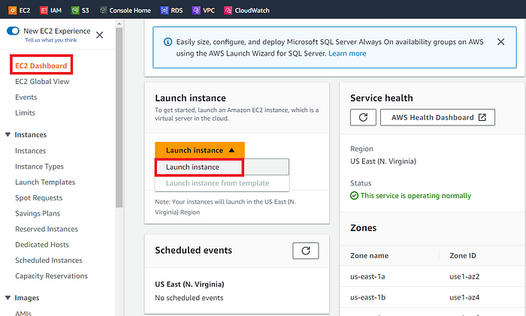

Once the **Launch an instance** window opens, provide the name of your EC2 Instance:

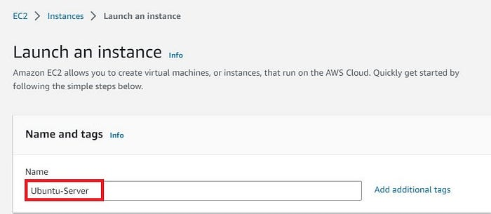

Let’s choose Ubuntu Server 20.04 which is free tier eligible.

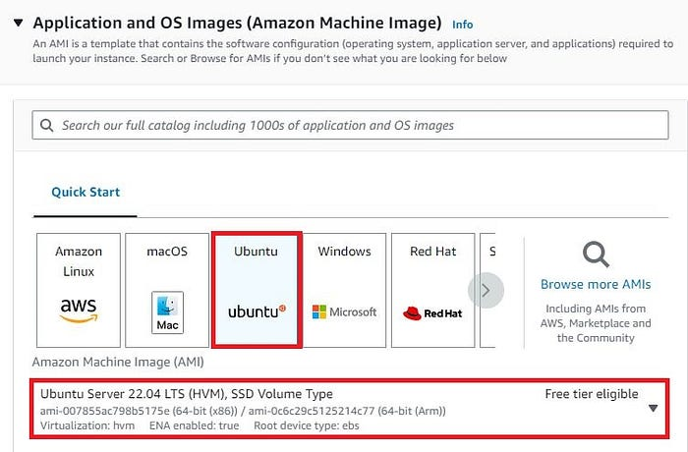

Now choose an **Instance Typ**e. Here you can select the type of machine, number of vCPUs, and memory that you want to have. Select t2.micro which is free-tier eligible.

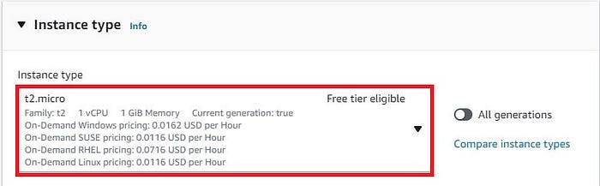

For this demo, I will select an already existing key pair. You can create new ones in case you don't have any existing ones.

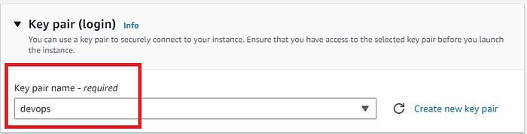

Now under **Network Settings**, Choose the default VPC with Auto-assign public IP in enable mode. Choose an existing **security group** that we have been using in all our previous projects with port 8080 open apart from SSH.

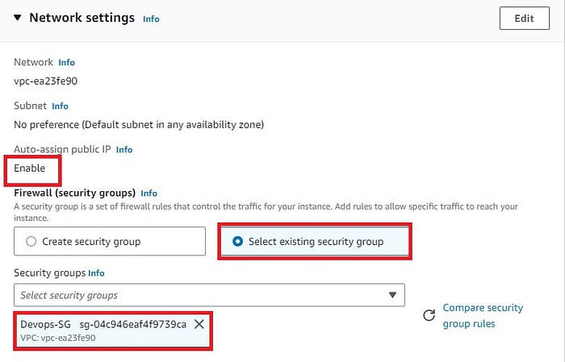

Rest of the settings we will keep them at default and go ahead and click on **Launch Instance**

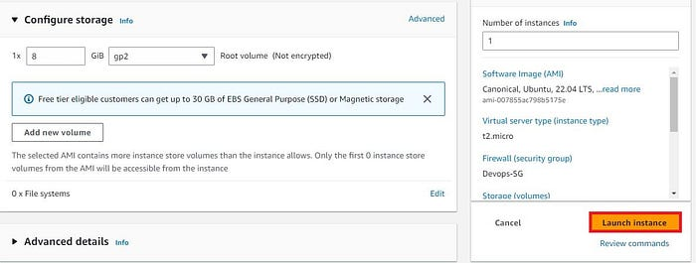

On the next screen you can see a success message after the successful creation of the EC2 instance, click on Connect to instance button:

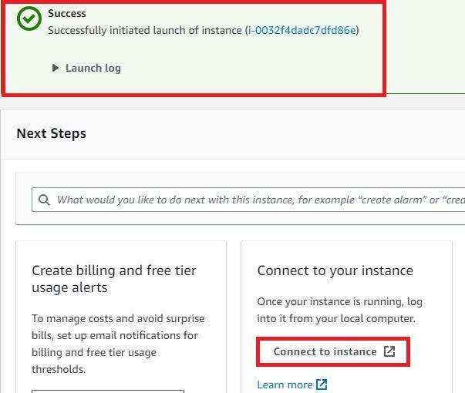

Now **connect to instance** wizard will open, go to SSH client tab and copy the provided chmod and SSH command:

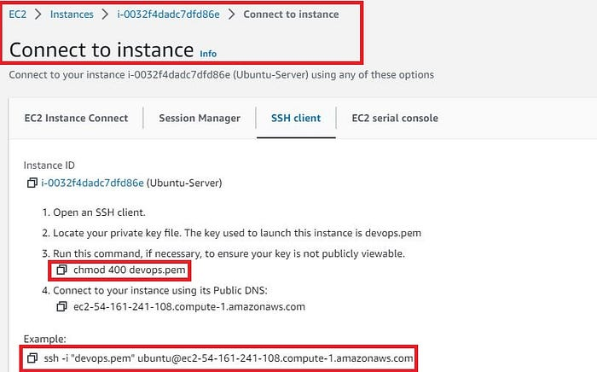

**Step 2: Install Jenkins on Ubuntu EC2 Machine**

If you have been following my blog you should have seen that we have been installing Jenkins either from the official Jenkins website or using Jenkins on docker containers. Here we will install Jenkins using a script that basically has the same steps which we can find on the Jenkins official website.

# Update package lists

sudo apt-get update

# Install Java 11

sudo apt-get install -y openjdk-11-jdk

# Download Jenkins key and add it to system

sudo wget -O /usr/share/keyrings/jenkins-keyring.asc \

https://pkg.jenkins.io/debian-stable/jenkins.io-2023.key

echo "deb [signed-by=/usr/share/keyrings/jenkins-keyring.asc]" \

https://pkg.jenkins.io/debian-stable binary/ | sudo tee \

/etc/apt/sources.list.d/jenkins.list > /dev/null

sudo apt-get update

sudo apt-get install Jenkins

(or)

sudo wget -O /usr/share/keyrings/jenkins-keyring.asc \

https://pkg.jenkins.io/debian-stable/jenkins.io-2023.key

echo "deb [signed-by=/usr/share/keyrings/jenkins-keyring.asc]" \

https://pkg.jenkins.io/debian-stable binary/ | sudo tee \

/etc/apt/sources.list.d/jenkins.list **>** /dev/null

sudo apt-get update

sudo apt-get install jenkins

Run above 4 commands one by one.

# Update package lists again to include Jenkins and install it

sudo apt-get update

sudo apt-get install -y jenkins

# Verify Jenkins is installed and working

sudo systemctl status Jenkins

Output: (this is yasmine output file)

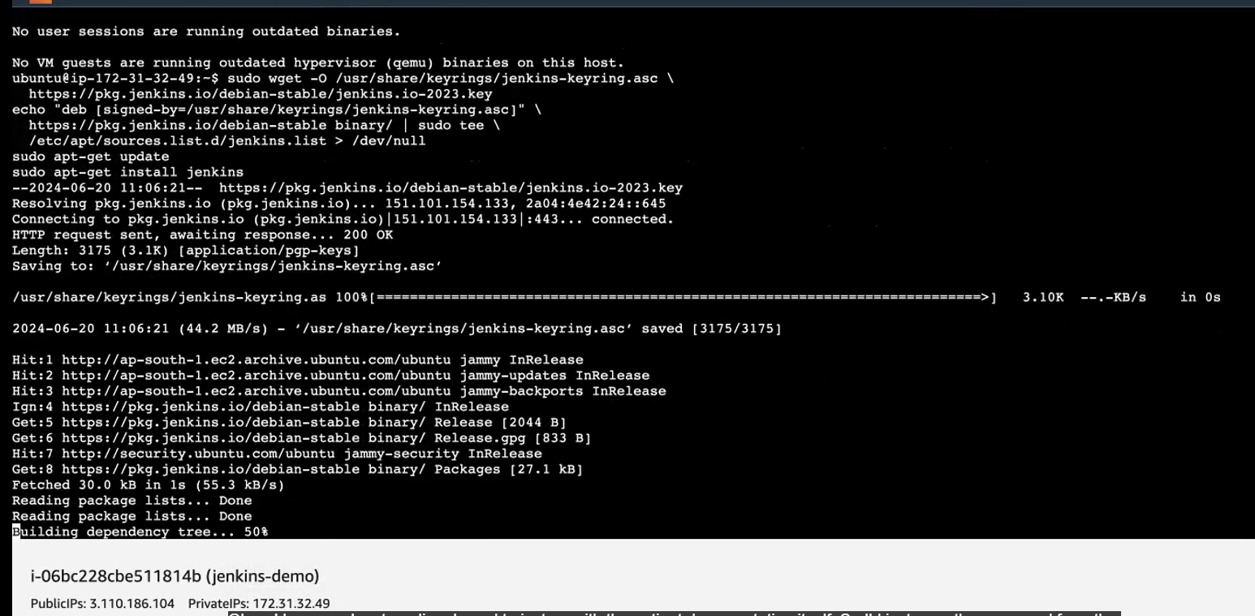

Let’s now verify the status of Jenkins: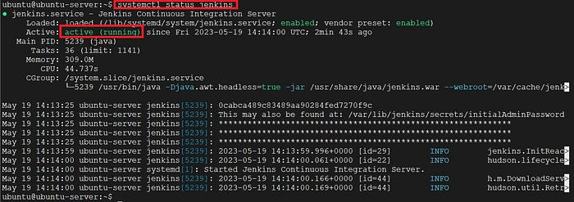

Lets now access the Jenkins Server using the public IP of our Ubuntu EC2 instance on port 8080 and you should see something like the below:

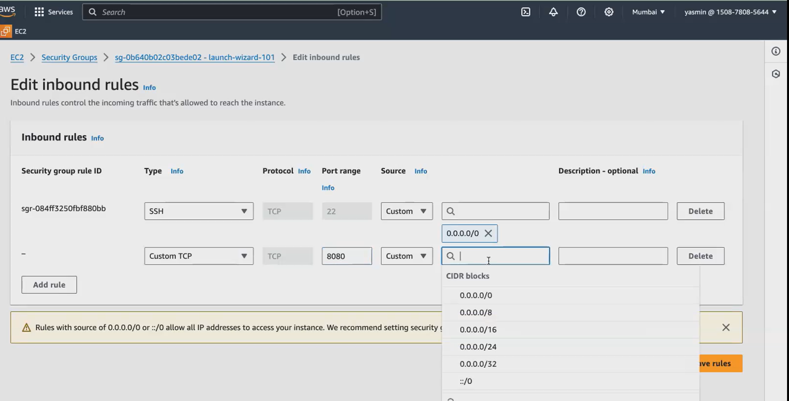

Open Jenkins in browser:

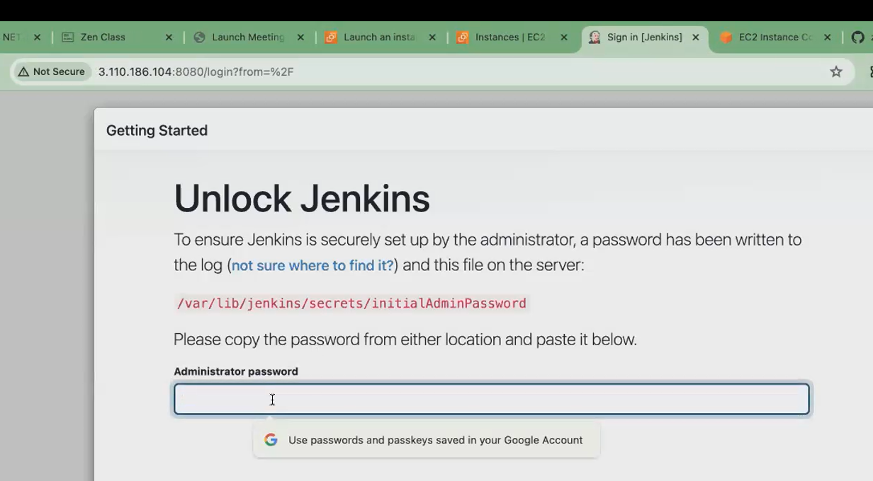

Get the password ,run the below command:

sudo cat /var/lib/Jenkins/initialAdminPassword

copy the password (ebfa701……) in administrator password

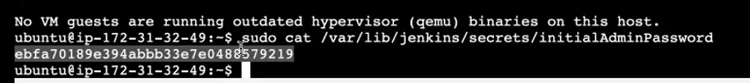

Navigate to /var/lib/jenkins/secrets/initialAdminPassword and copy the password and unlock Jenkins.

Then Install the suggested plugins:

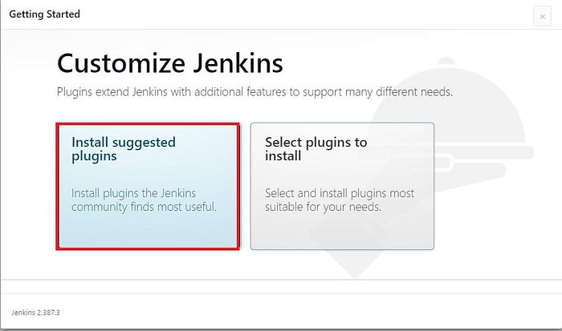

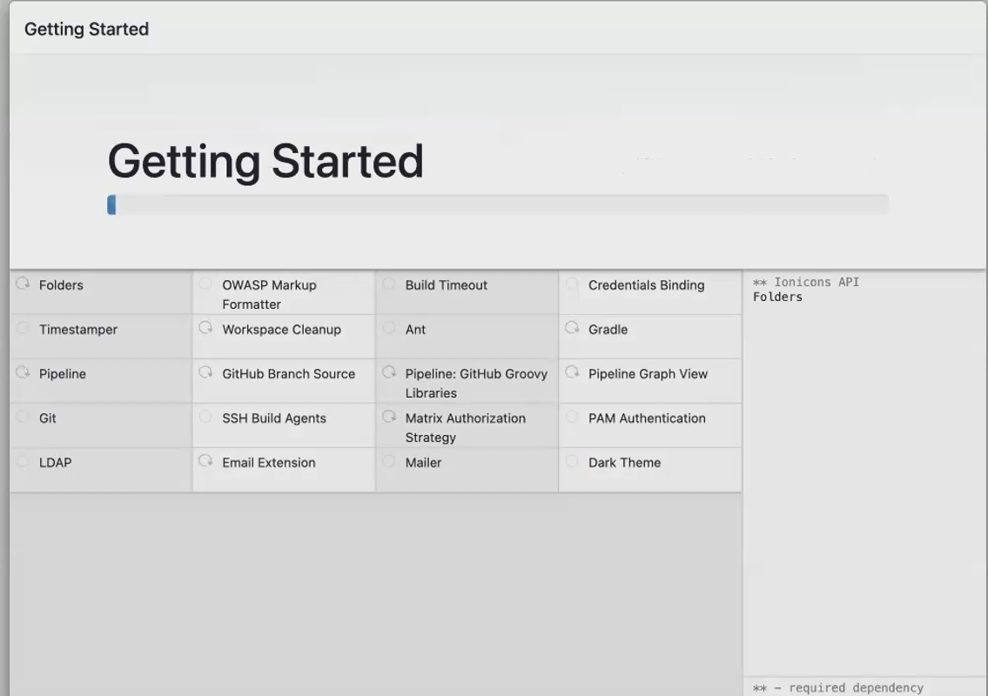

Now let’s create our first Admin user and provide the required info:

Give username as admin, then only we can access all inside Jenkins. In username don’t give your name.In full name you give your name or any other name can be given.

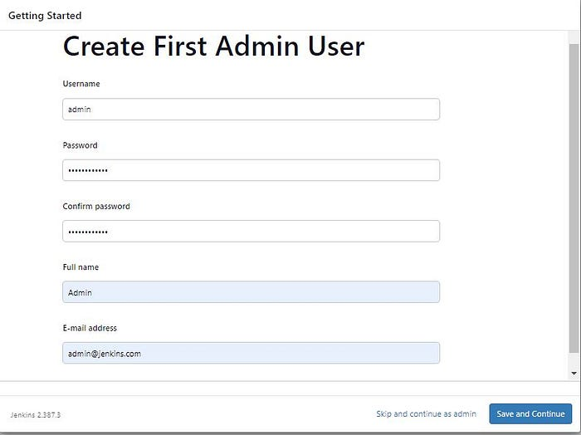

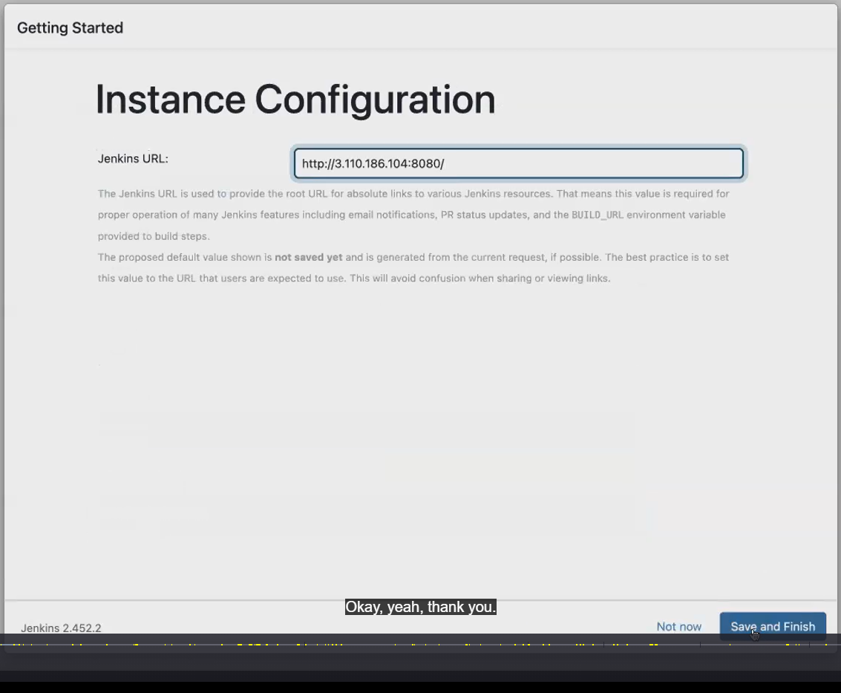

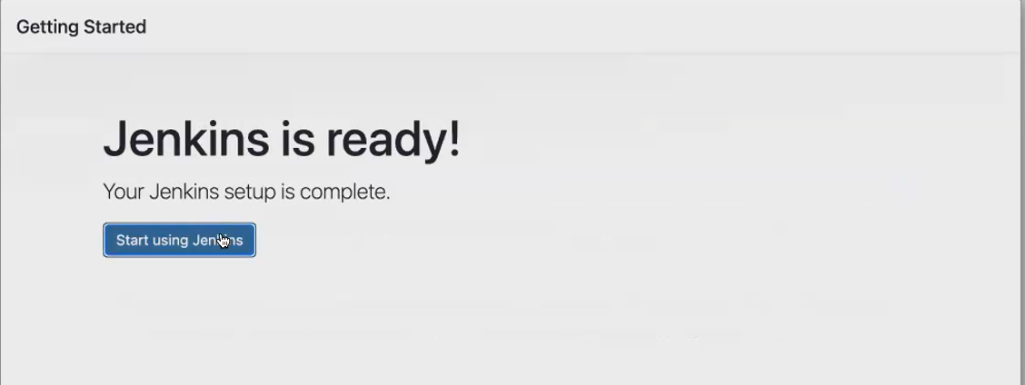

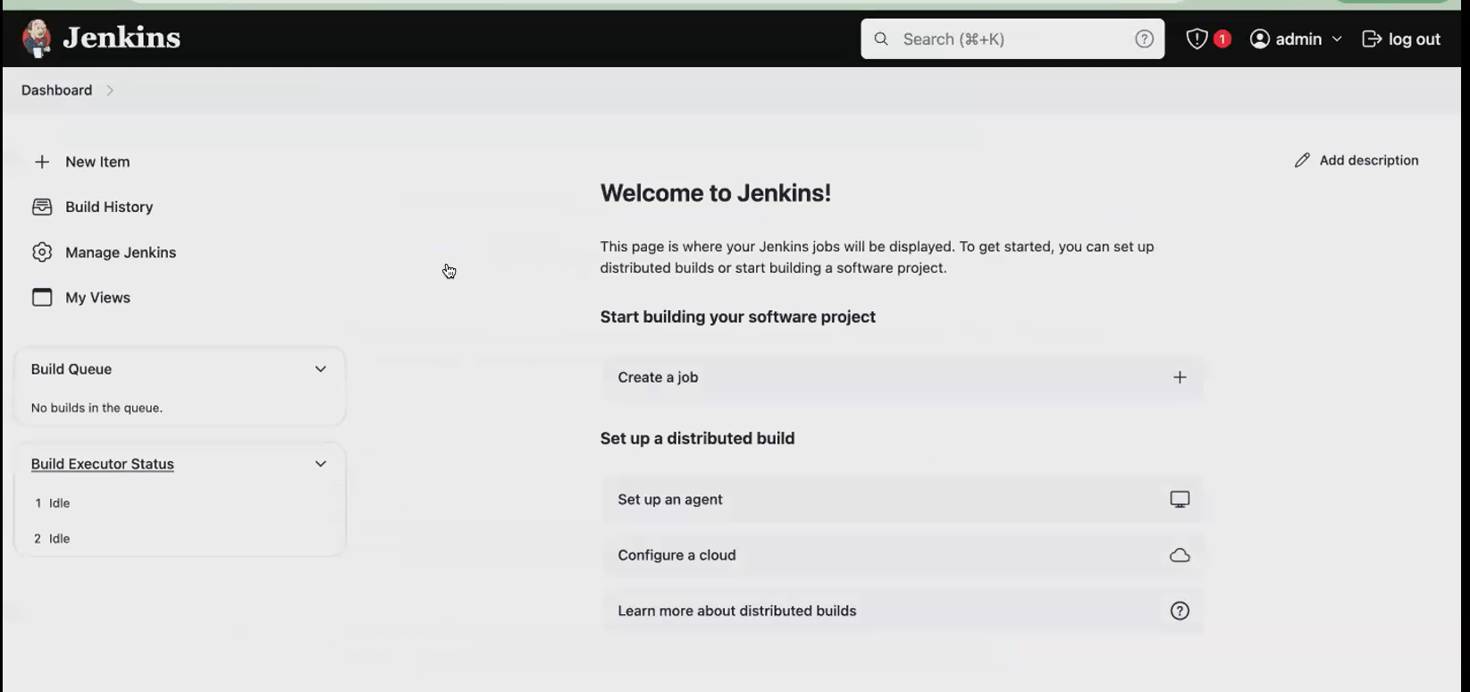

After creating the user we should land into the Jenkins dashboard and let’s install the Docker Plugin.

Click on Manage Jenkins -> Manage Plugins -> Available Plugins and **install without restart** the Docker plugin.

In github repo,we have docker file..so we installed

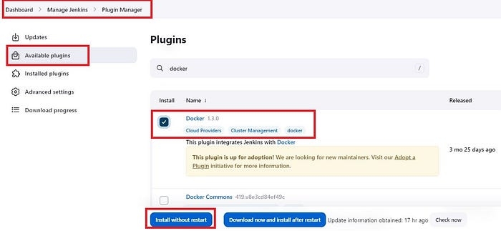

**Step 3: Install Docker in ec2**

After the successful installation of Docker in Jenkins ,install docker in ec2 also.

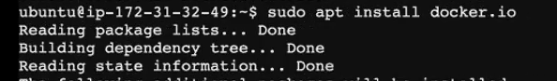

sudo usermod -aG docker Jenkins

sudo systemctl restart jenkins

Give docker permission for Jenkins. Then only we use docker in jenkins



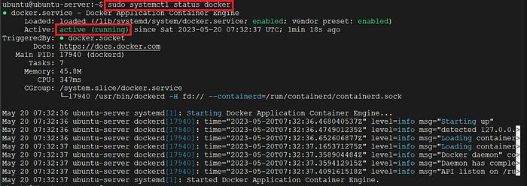

Add the jenkins user to the docker group and refresh the Jenkins page/server. Again ask for sign in.

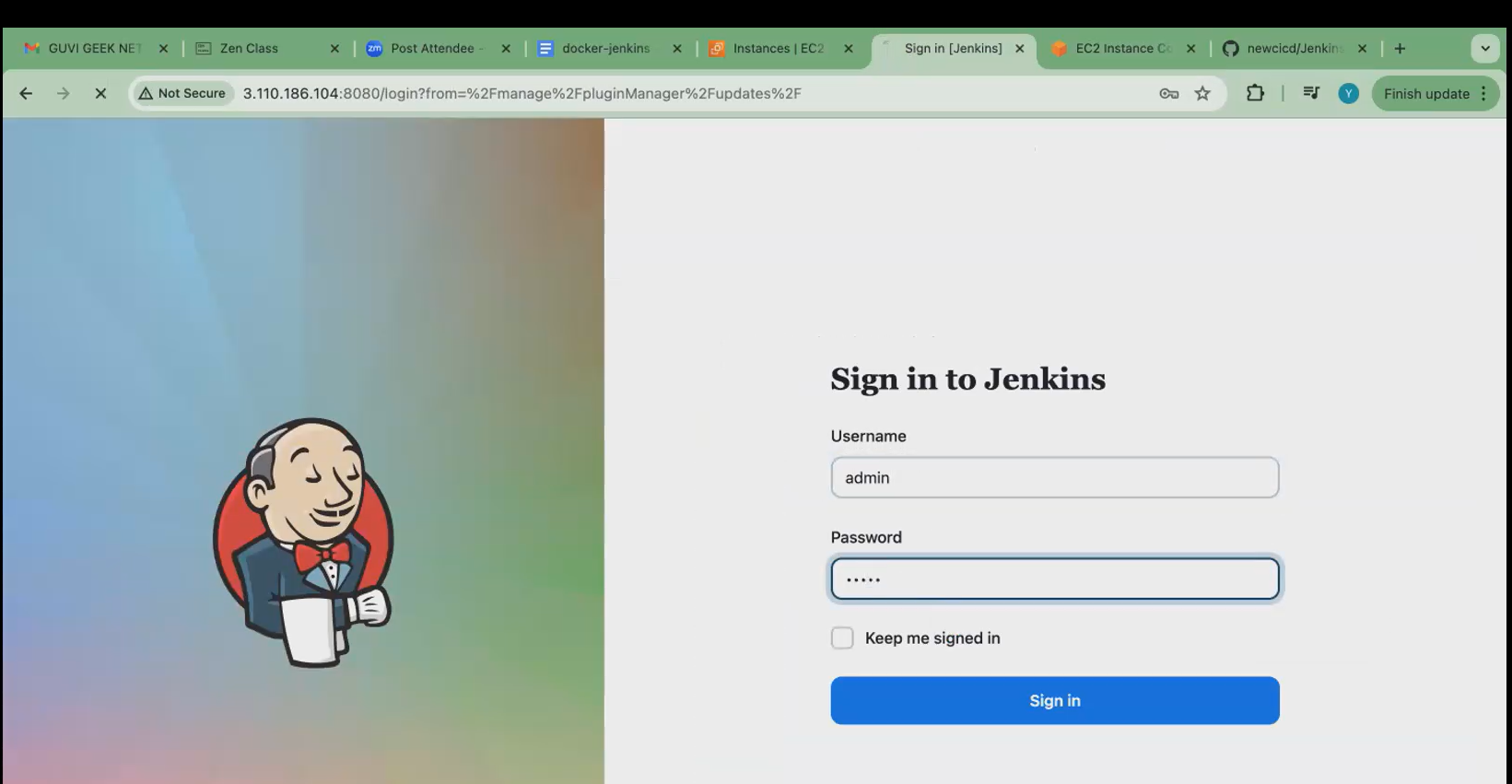

**Create a project:**

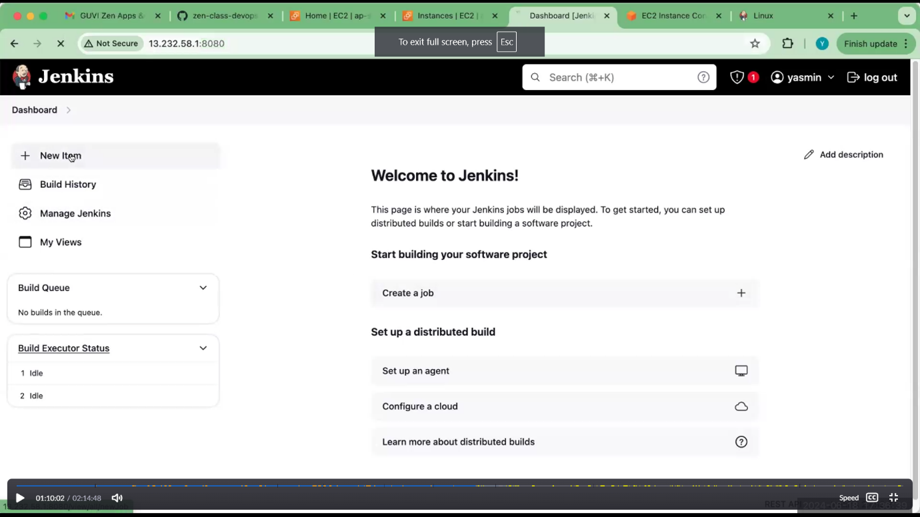

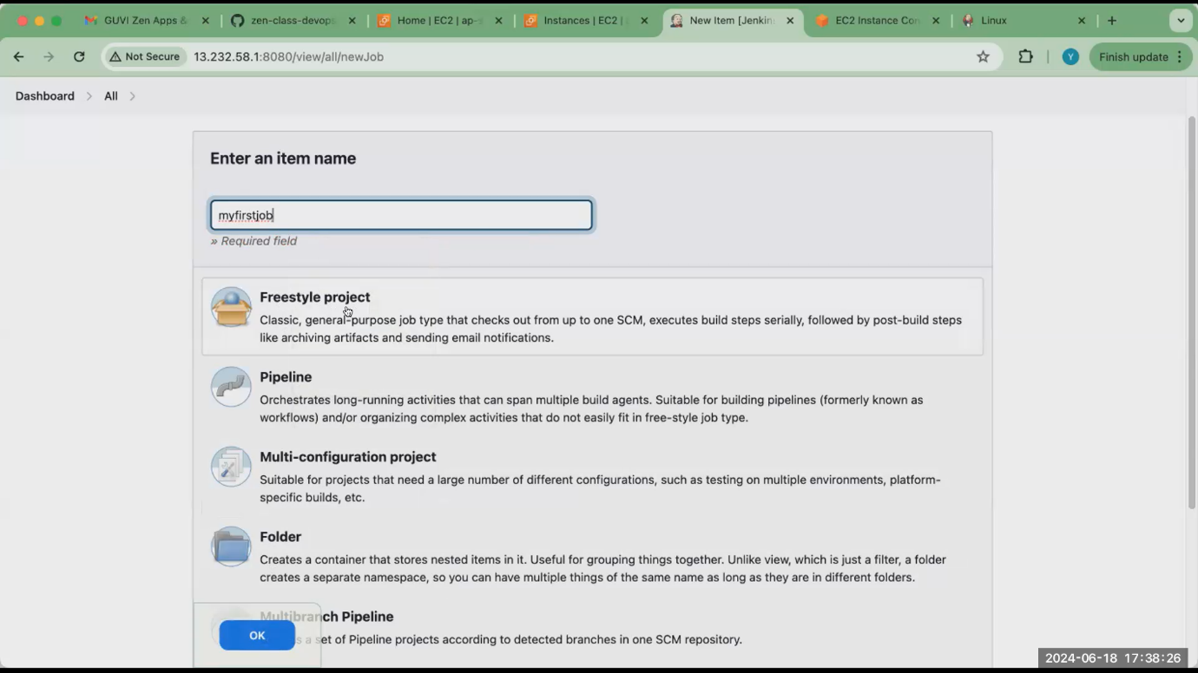

Jenkins get a job in github.

<https://github.com/yasminjeelani/my-to-do-cicd.git> (yasmine github link for creating this project)..by using fork option copy yasmine github to my GitHub. After fork ,our code generated. Copy this and paste it in Jenkins.

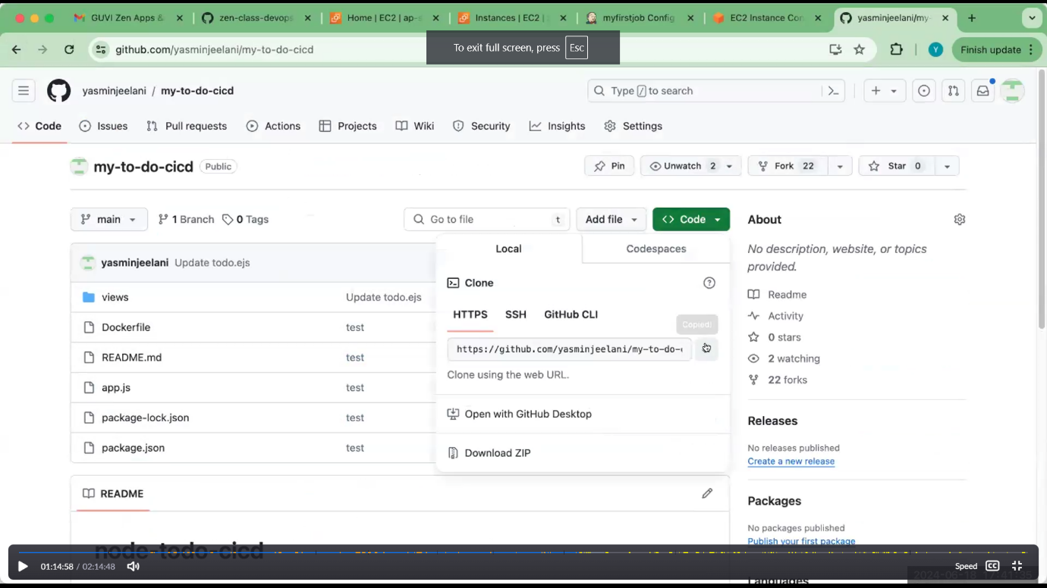



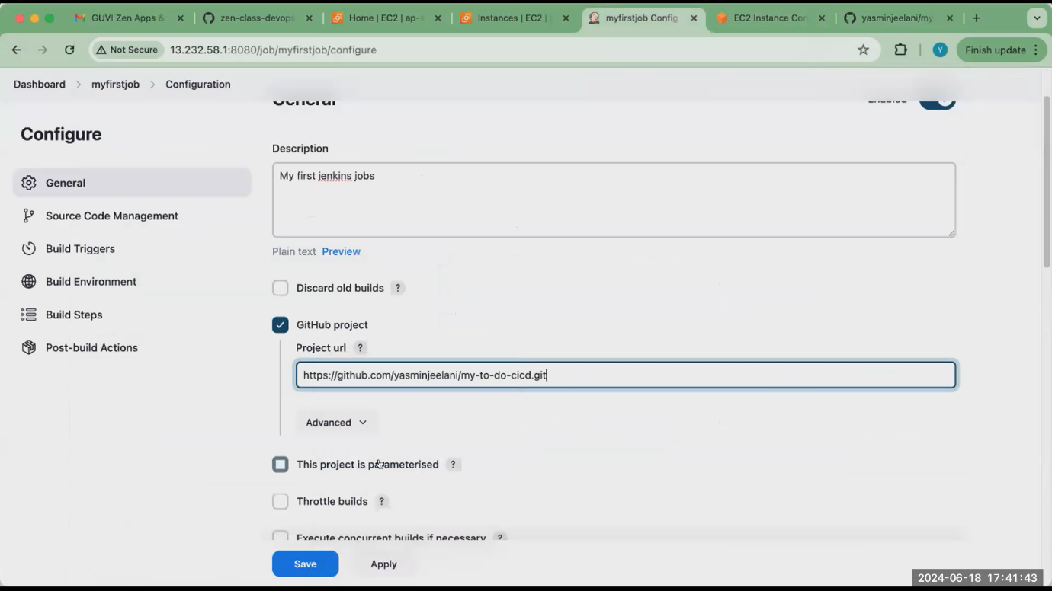

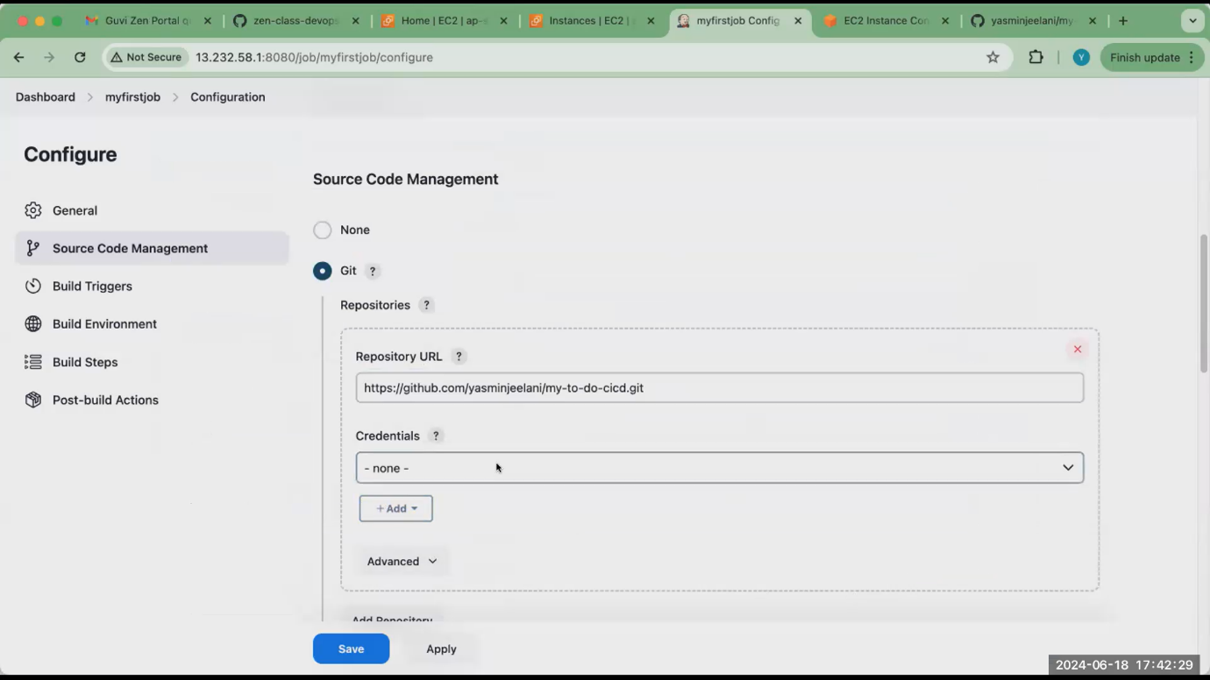

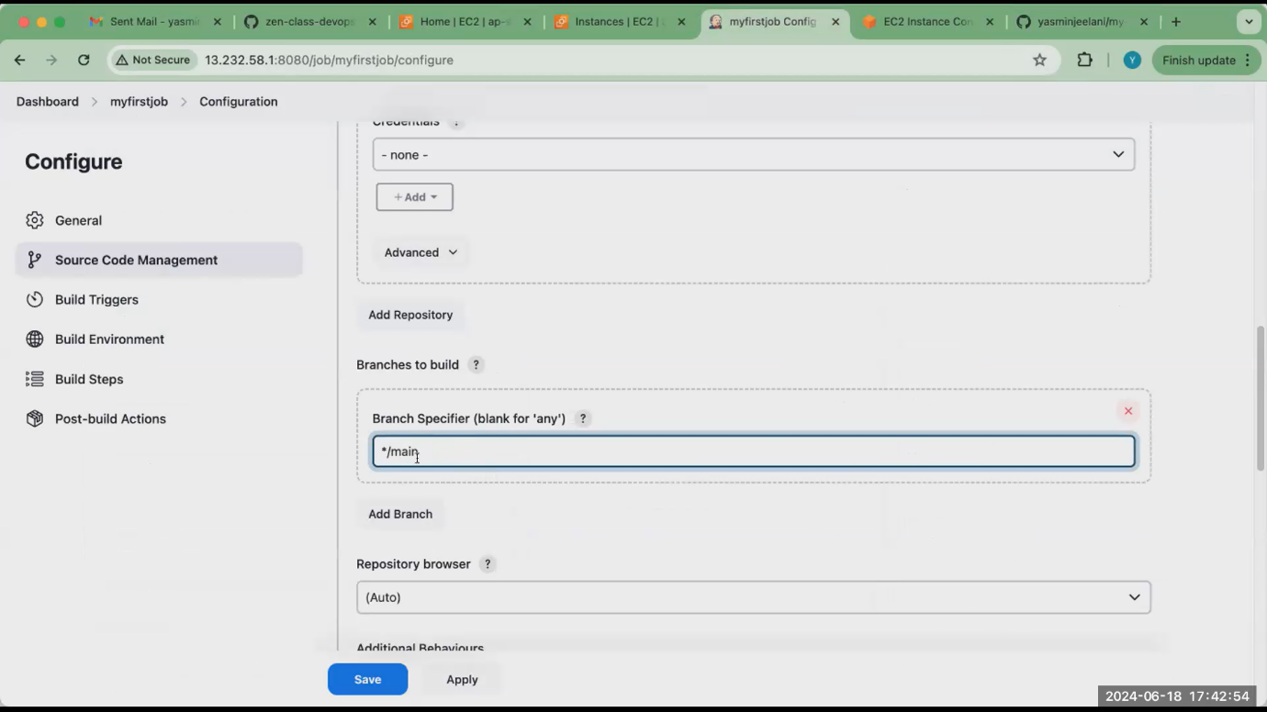

We have run this in shell.so select this

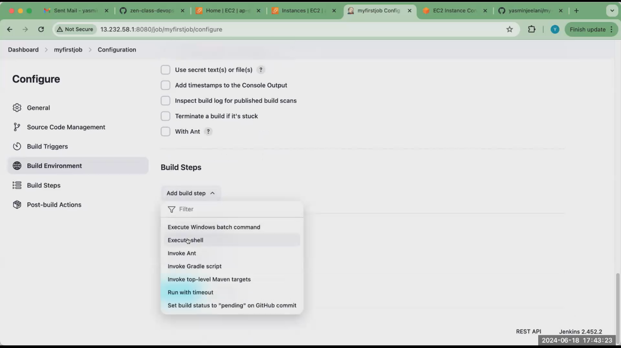

In github repo ,we have dockerfile .so build the image and run that image.give that command in execute shell.

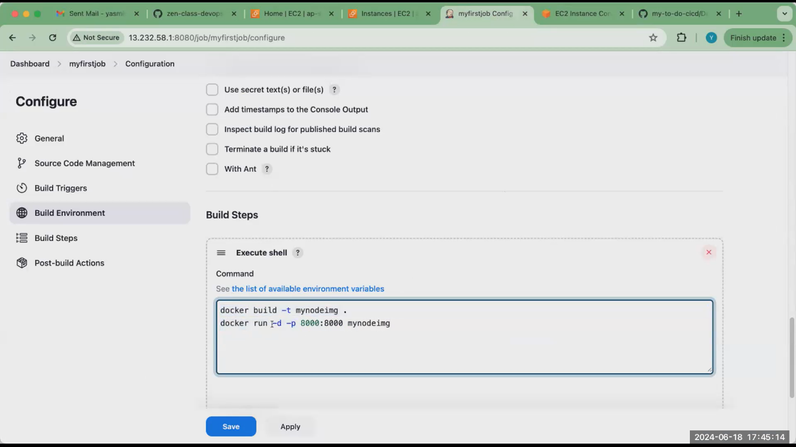

After this apply and save.

**In step 3 install docker in ec2..before build this job check docker installed or not.**

**After apply and save our project created:** 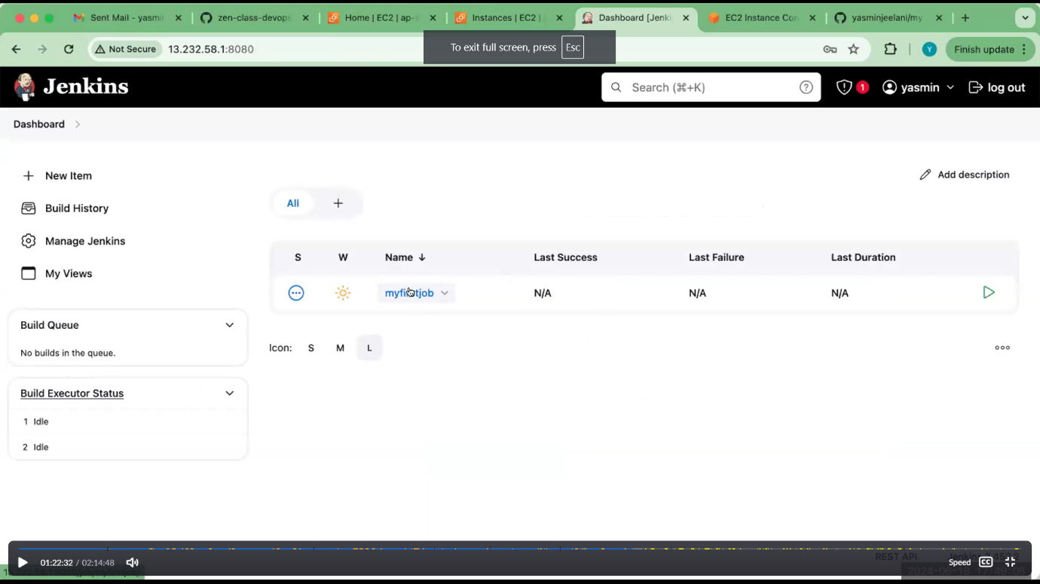

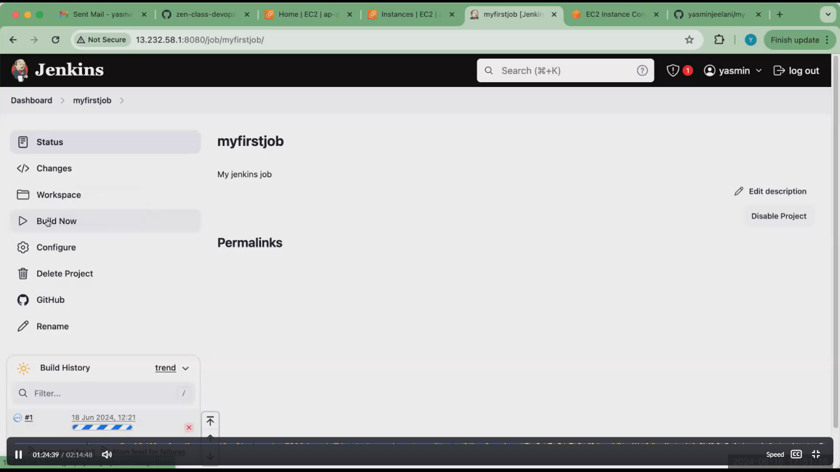

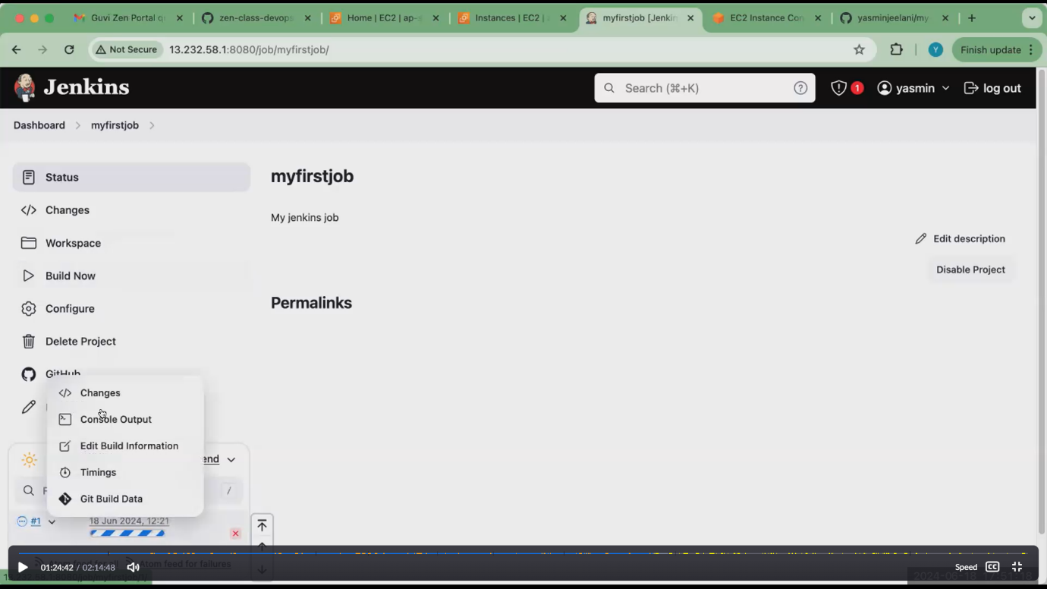



**After select build now ,click console output. If you have no error console output was success.**

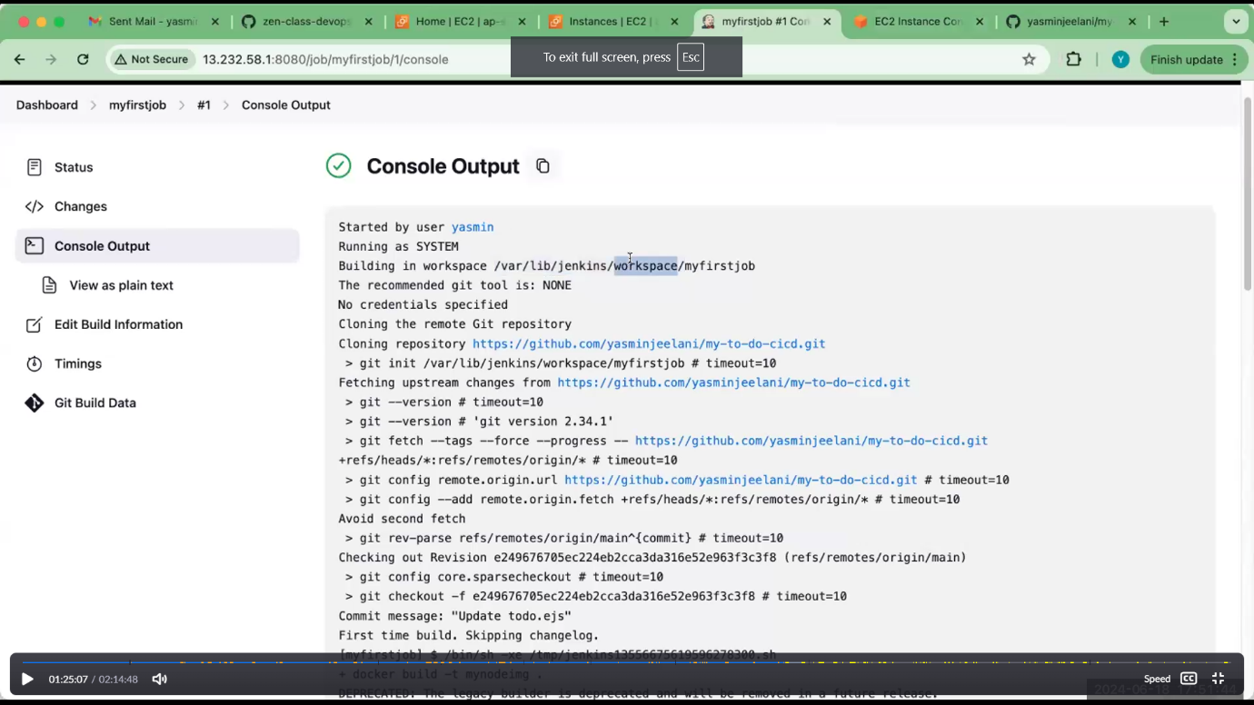

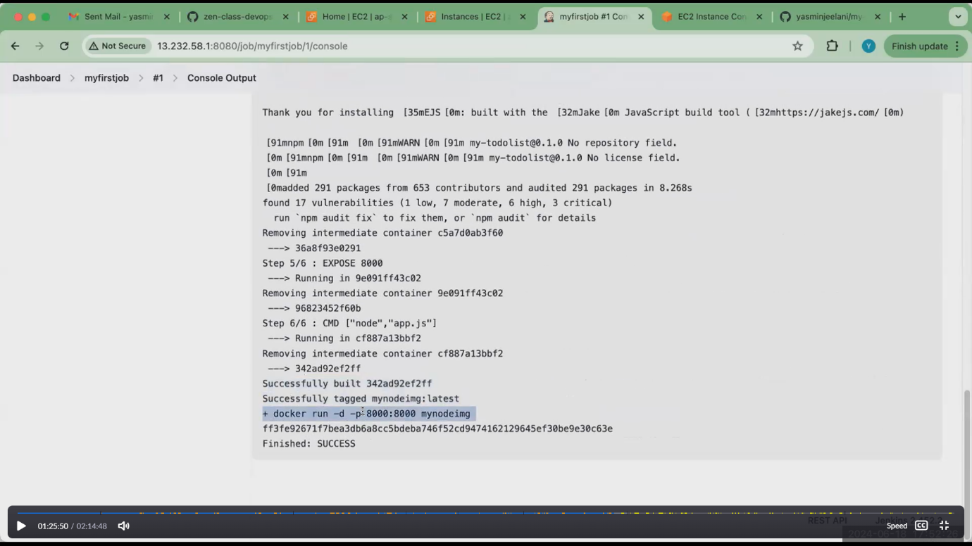

**Application run in port no: 8000.open the port no in ec2**

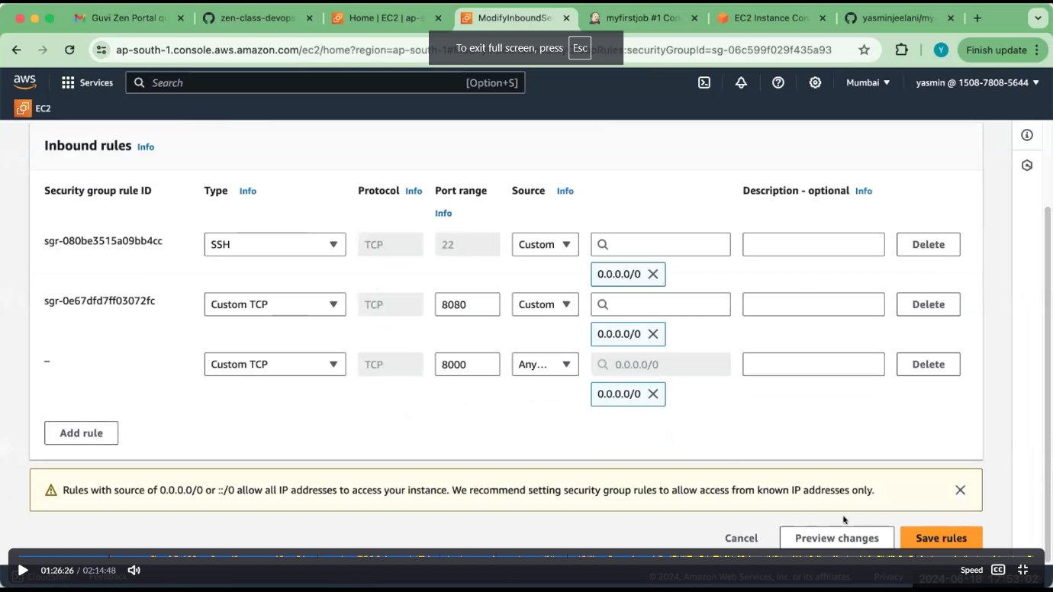

**Jenkins get the application from github and runs**

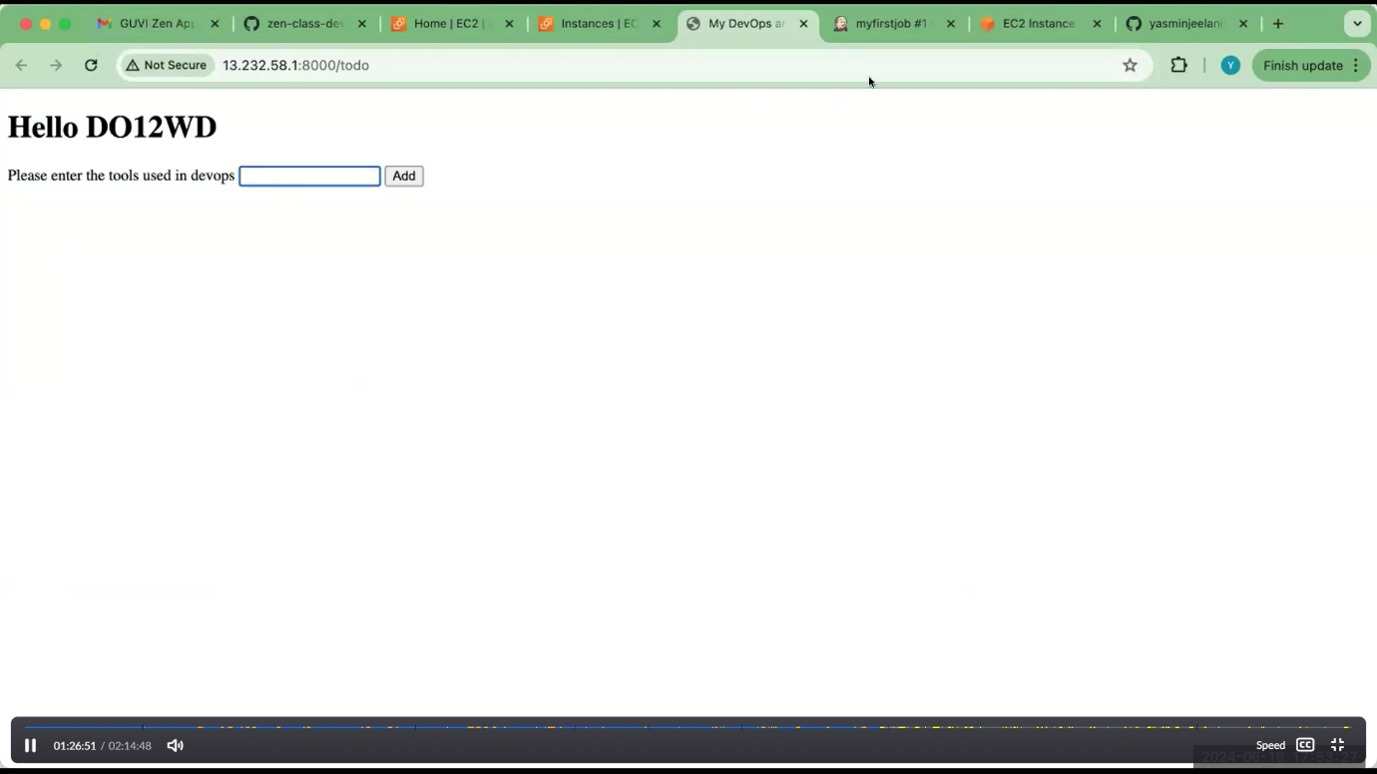

**Now simple jenkin project can created successfully.**

1. **Create users (developer):**

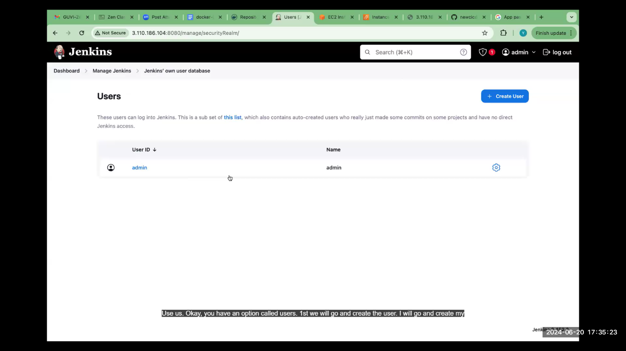

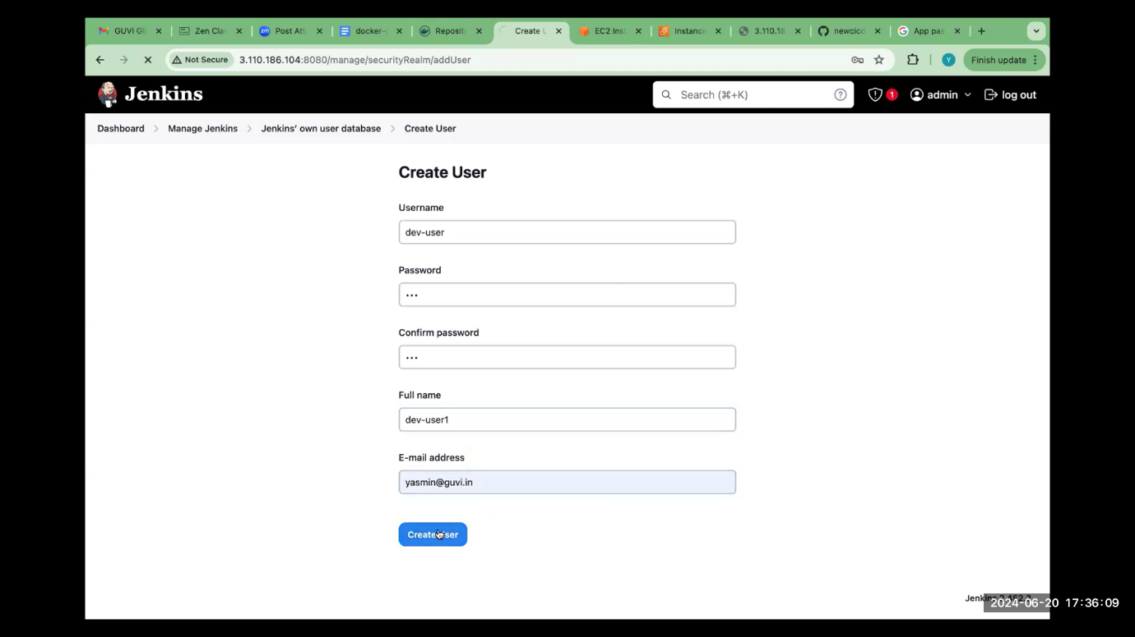

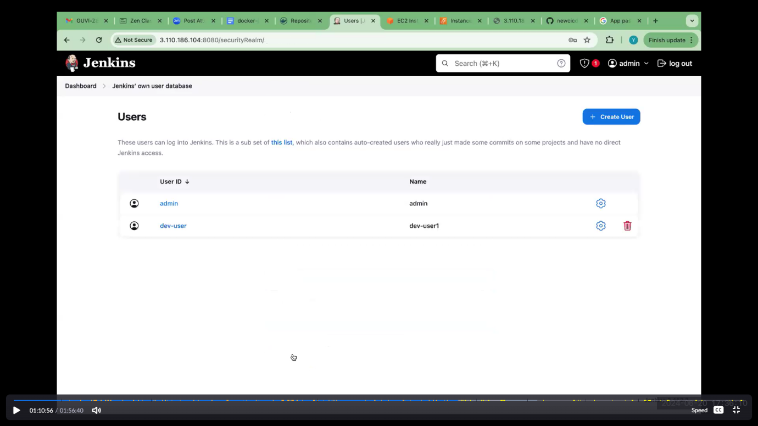

**Dev user created**

1. **Create users (test user ):**

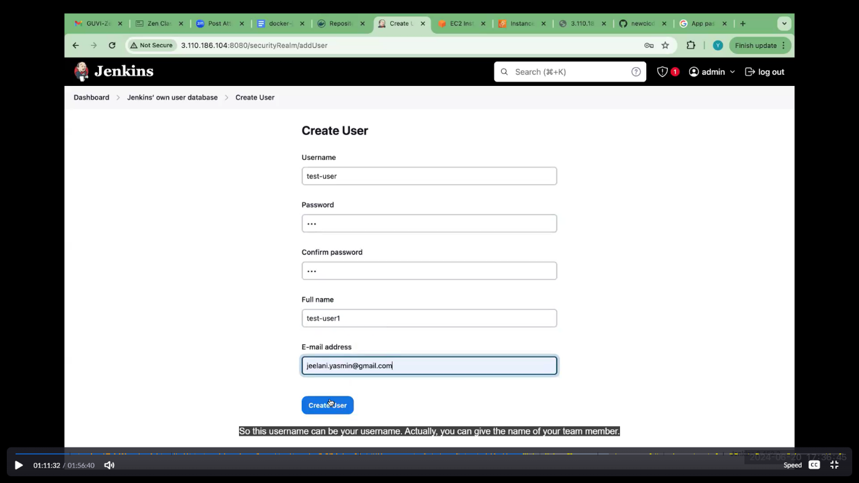

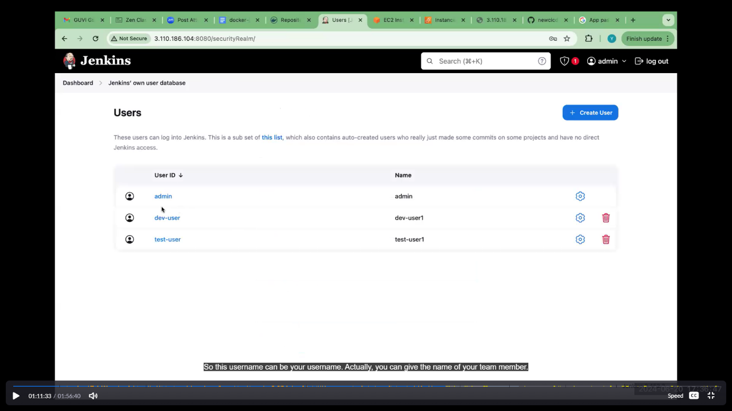

**Test user created**.

**In dashboard you have to see the users**

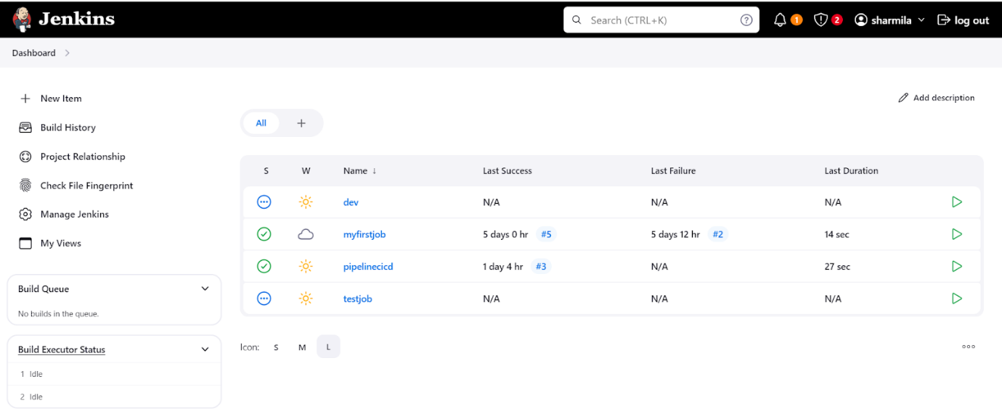

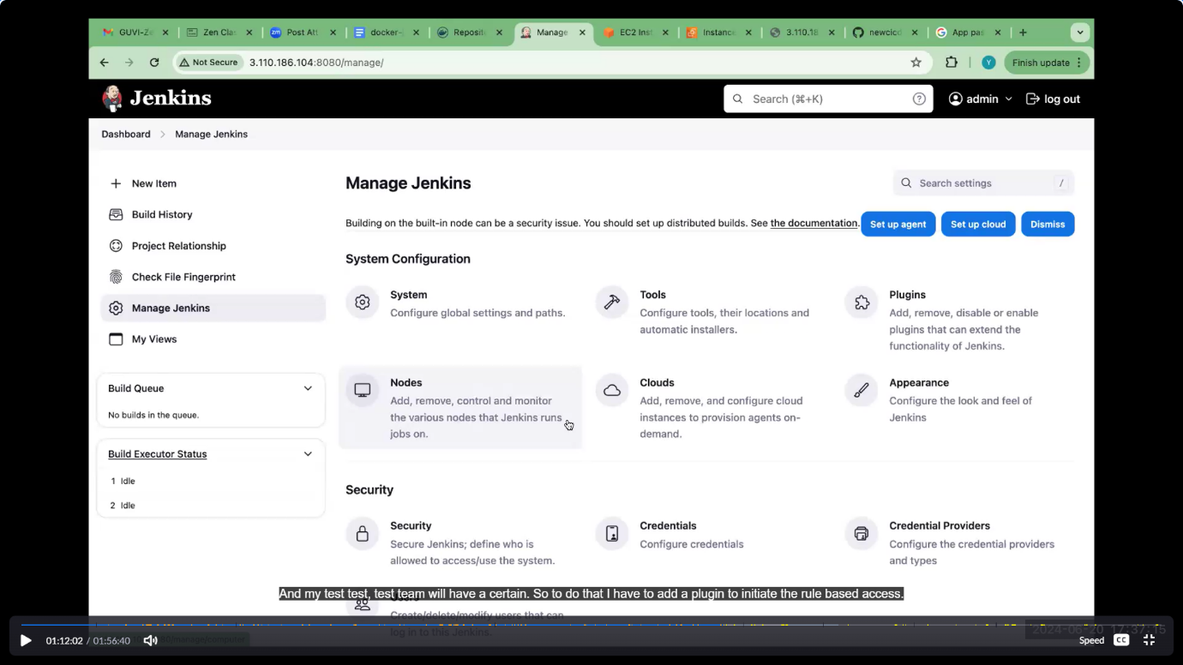

2 users can be created, after this ,we have to give permission for each users.for this we have to add plugin. Manage Jenkins-🡪pulgins🡪available pulgins🡪search role based authorization 🡪install

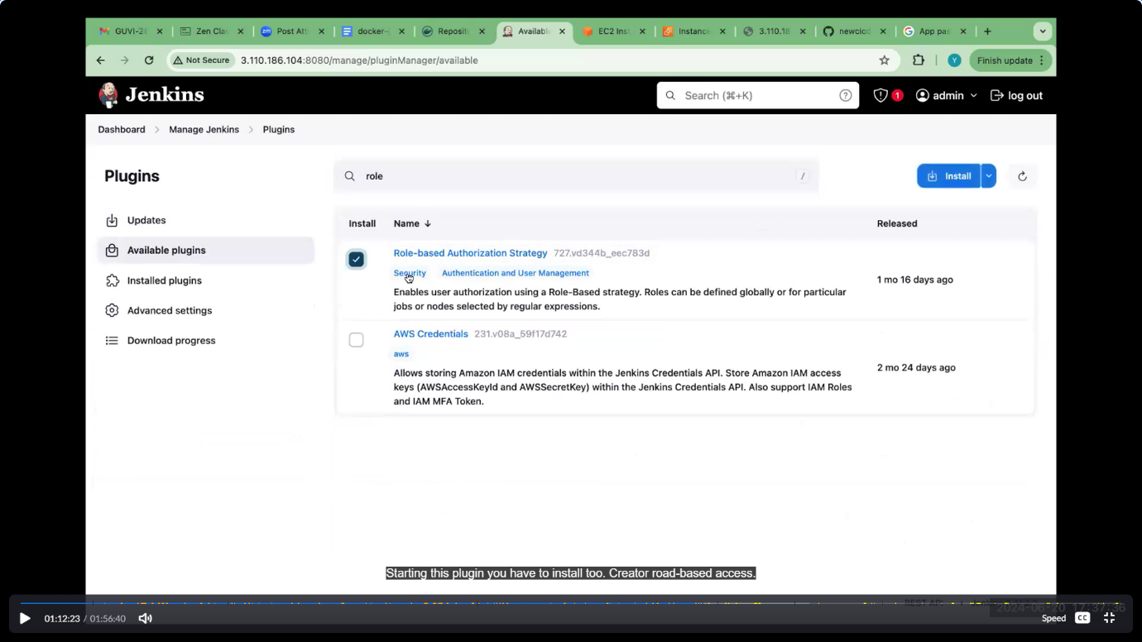

After installed role based authorization, go to manage Jenkins🡪security

Change allow users signin to role based strategy.

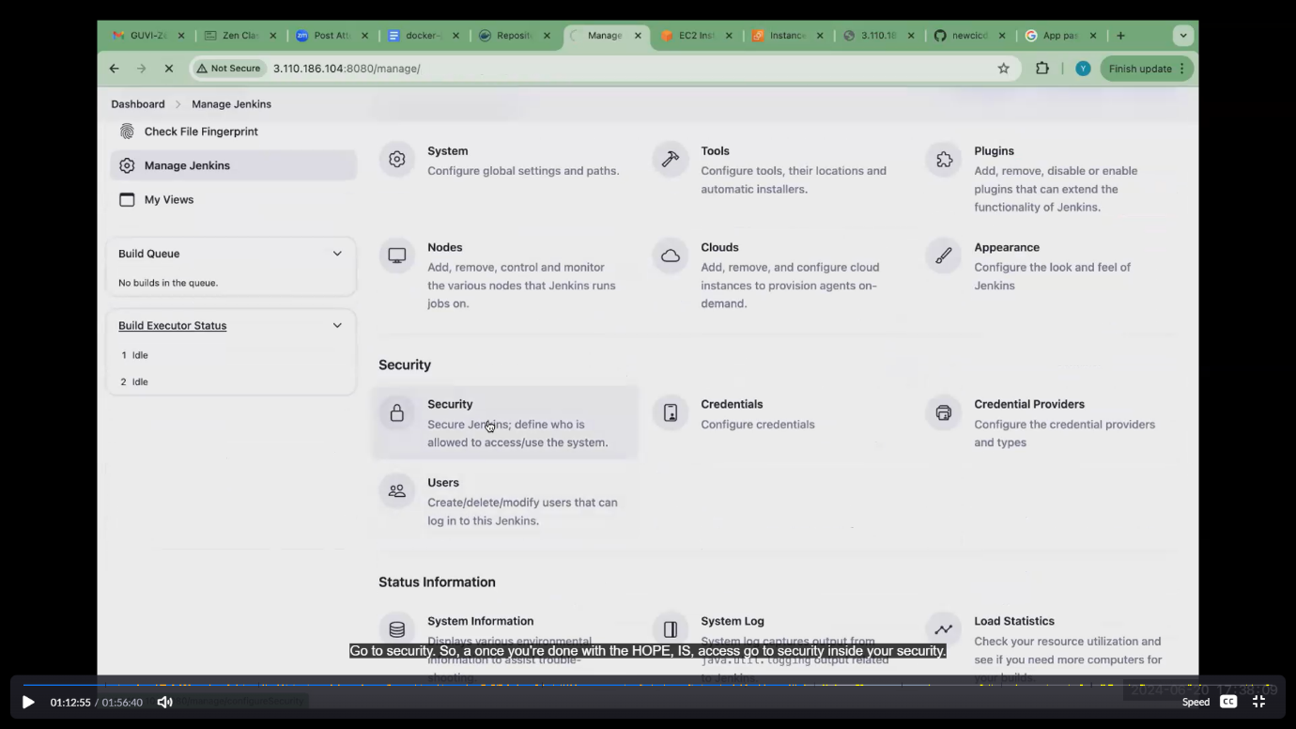

Change allow users signin to role based stratagy.then only we have to give permissions for each users. Then click apply 🡪save.

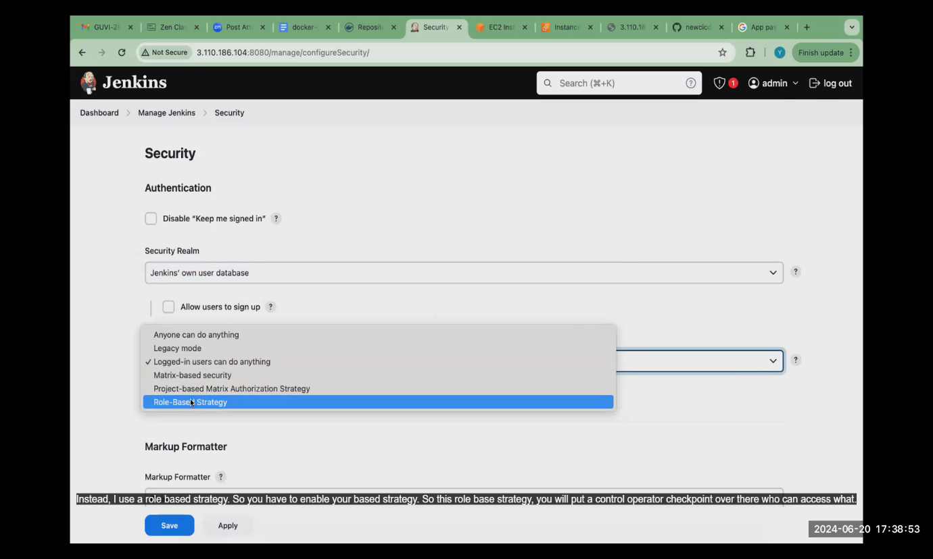

After that refresh the Jenkins page ,manage and assign role option available..

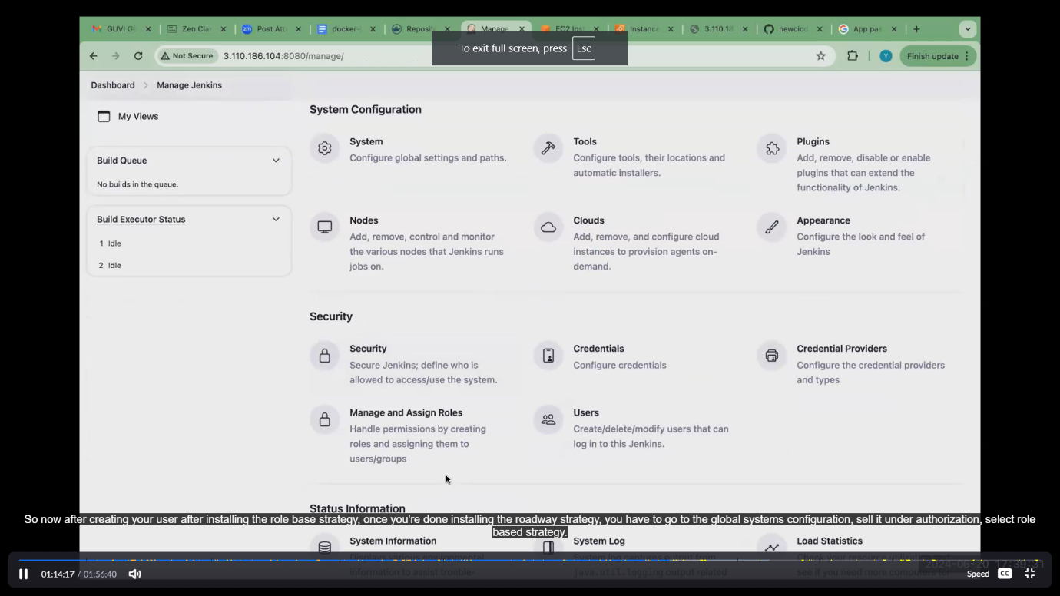

1. **Manage roles:**
2. **Global roles:**

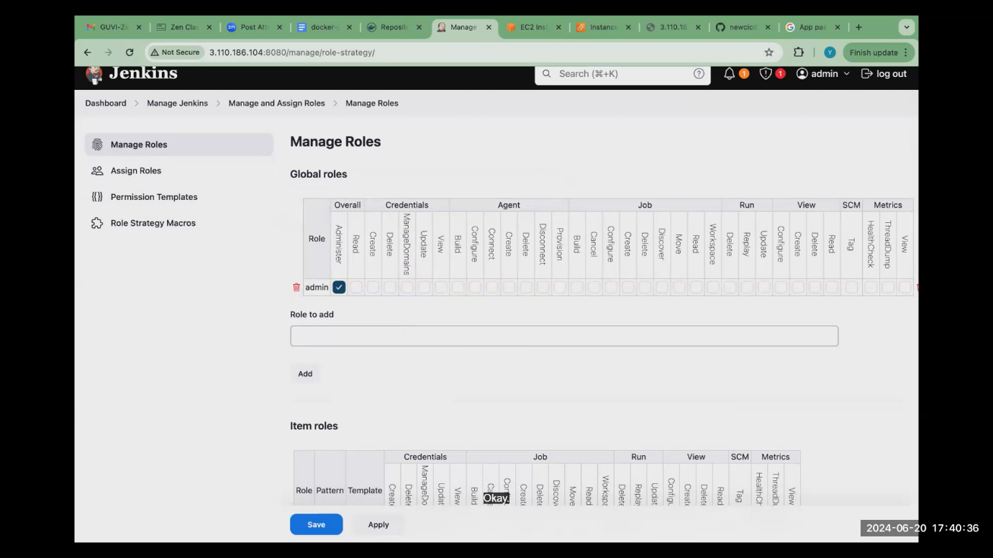

Click add you have to add employee. Give permission as I gave

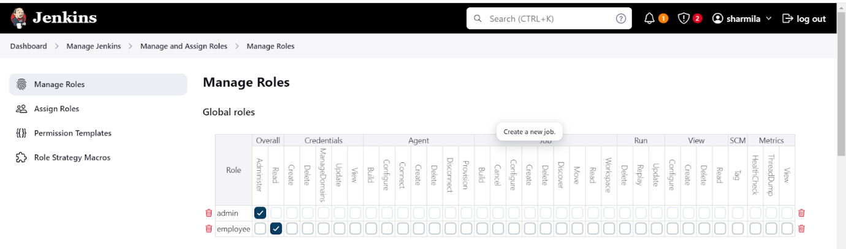

1. **Item role:**

**Pattern matched with job we create..so give the same pattern becz its case sensitive.**

**Dev user:**

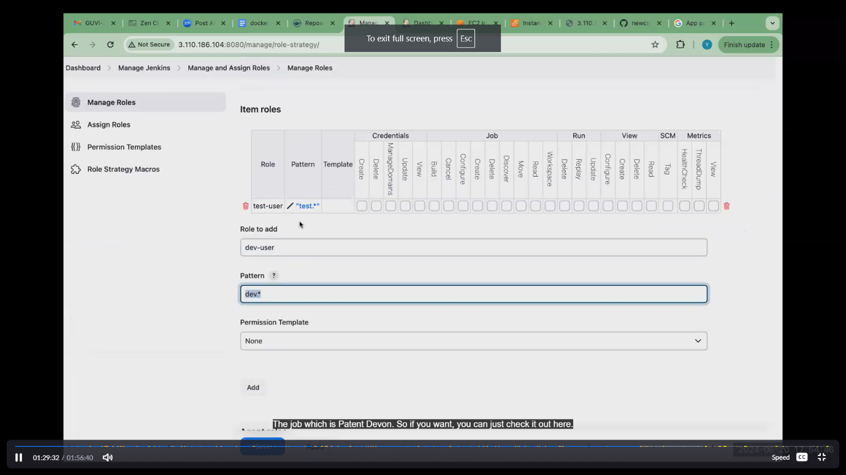



**Test user:**

**Similar to dev user create test user ..permission gave as per in image**

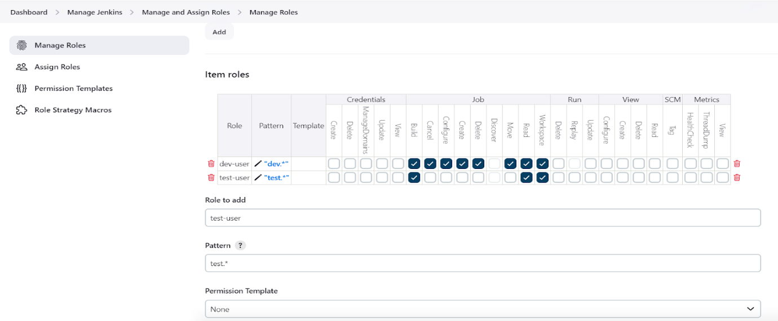

1. **Assign roles (global and item roles):**

Click add user add dev user-1 and test user-1



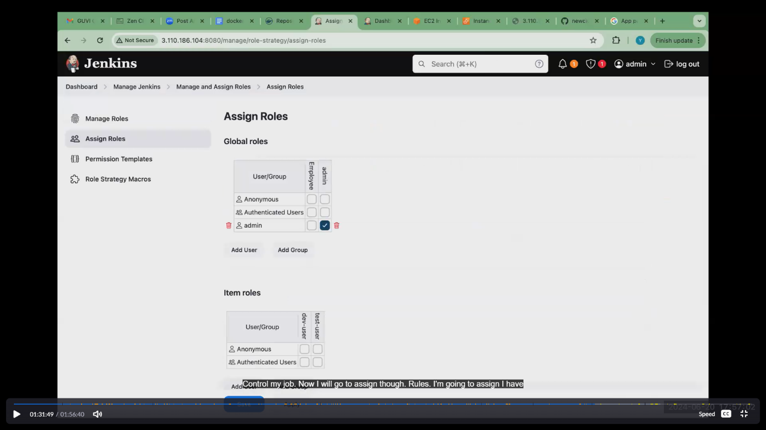

Click add user (global and item roles) add user id as dev-user1 and test-user1. Then apply and save.

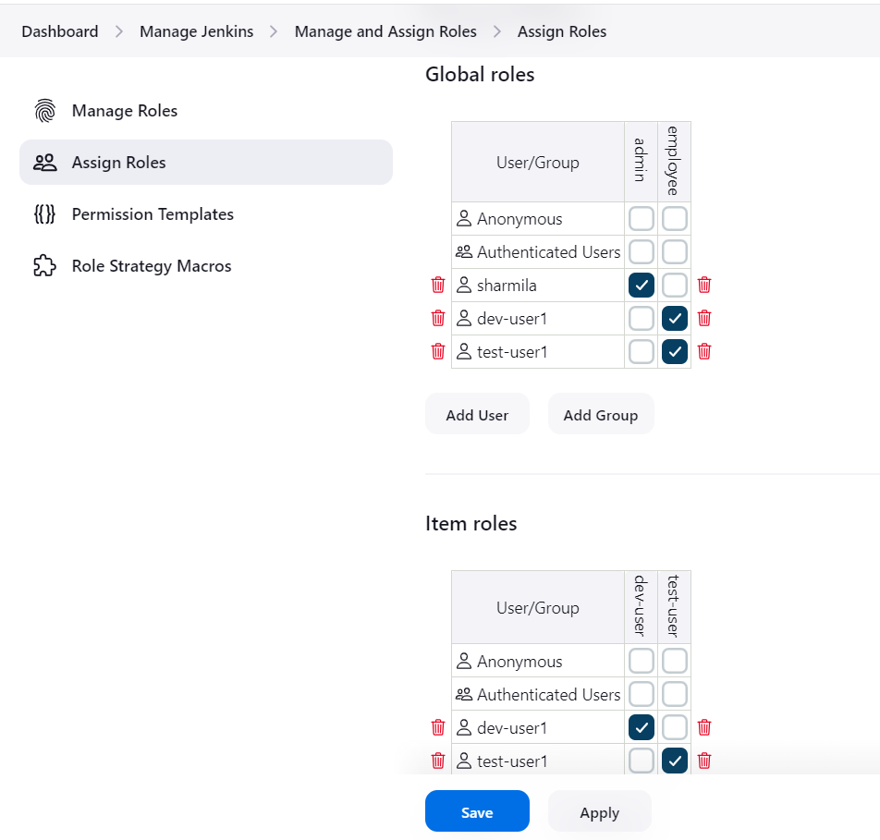

Logout admin ,sign in as dev user. At the time of creating job we give username and password.just for checking purpose we have to login

**Sign in to dev user:**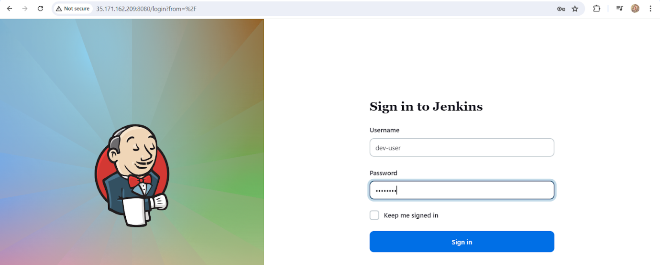

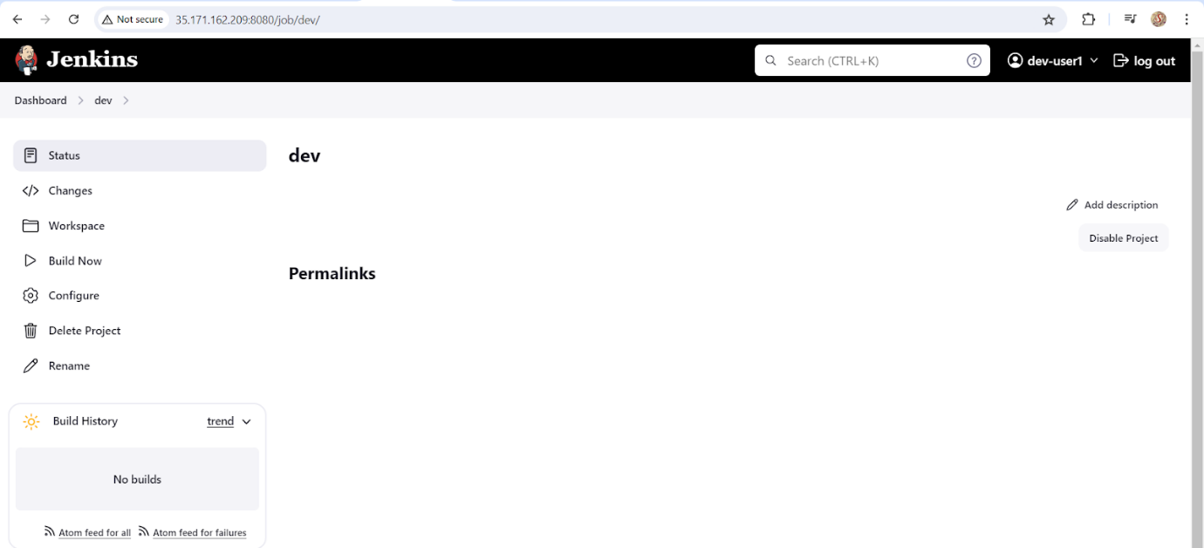

**Sign in to test user:**

Logout admin ,sign in as tset user. At the time of creating job we give username and password.

